Stochastic Cells *

Dimerization: monomer (*M*) joins up with another monomer and becomes a dimer (*D*): 2*M* ↔ *D*. The forward reaction rate is $k_{b }$ and the backward reaction rate is $k_{u}$. There are two reactions:

* the backward unbinding reaction ($r_{u}$) rate per unit volume is $k_{u}[D]$,
* the forward binding reaction rate ($r_{b}$) per unit volume is $k_{b}[M]^{2}$. Assume that: $k_{b}$ = 1n $M^{-1}s^{-1}$, $k_{u}$ = 2 $s^{-1}$, at *t* = 0 are only *N* monomers.

1. Continuum dimerization. Find equations for d*M*/d*t,* d*D*/d*t* and write code to simulate continuum dimerization.
2. Stochastic dimerization. Implement algorithm:
3. Calculate a list of the rates of all reactions in the system.

for discrete molecules:

${r_{b} = k}_{b}M(M-1)$,

$r_{u} = k_{u}D$,

1. Find the total rate ($r_{t}$*): $r_{t} =r_{b} + r_{u}.$*
2. Pick a random time $t_{wait}$ with probability distribution: $ρ(t)= r_{t} exp(-r_{t} t)$.
3. If the current time *t* is bigger than $t_{wait}$, no further reactions will take place, end.
4. Otherwise:

* increment *t* by $t_{wait}$,
* pick a random number *r* uniformly distributed in the range [0, $r_{t}$),
* pick the reaction j:

if *r* < $r_{b}$:2*M* → *D*

else: *D* → 2*M,*

* execute that reaction by incrementing each chemical involved by its stoichiometry

1. Repeat.

**C)** Compare A) and B) for:

*N* = 2, *N* = 90 and *N* = 10 100.

**\*** The assignment is from the book “Statistical Mechanics: Entropy, Order, Parameters and Complexity” by James Sethna (p. 178-179).

Results:

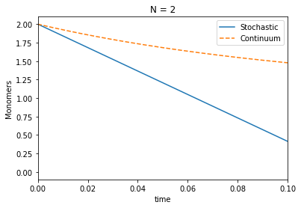

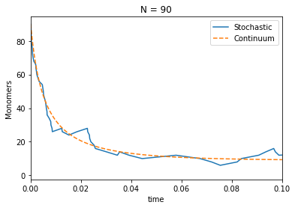

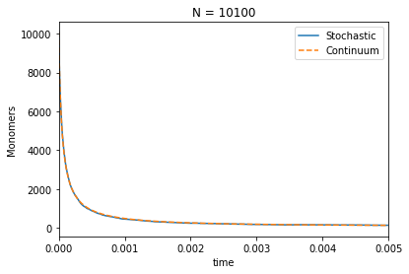

Hints:

**A)**

equations for: d*M*/d*t* and d*D*/d*t*:

$dM/dt = -2k_{b}M^{2}+2k_{u}D$

$dD/dt = -k_{u}D+k_{b}M^{2}$

to calculate the integrate you can use: scipy.integrate.odeint()

**B)**

to find $t_{wait}$ use scipy.stats.expon.rvs(), remember to set scale,

to choose *r* use random.randrange().